Program Title: Student Utility Program using Java
1. Aim
To develop a menu-driven Java program that performs student information processing, conditional operations, looping operations, and user-defined methods.
2. System Requirements
Hardware requirements
- Processor: Intel i3 or equivalent
- RAM: Minimum 4 GB
- Storage: Minimum 500 MB free space
Software requirements
- Operating System: Windows/Linux
- Java Development Kit (JDK)
- IDE: Eclipse, IntelliJ IDEA, or any text editor
- Command Prompt/Terminal for compilation and execution
3. Algorithm / Logic
- Start the program.
- Display the menu of available operations.
- Read the user's choice.
- Use switch to execute the selected operation.
- Accept the required input values.
- Perform calculations using conditional statements, loops, or methods.
- Display the result.
- Repeat the menu until the user selects Exit.
- Stop the program.

4. UML Diagram

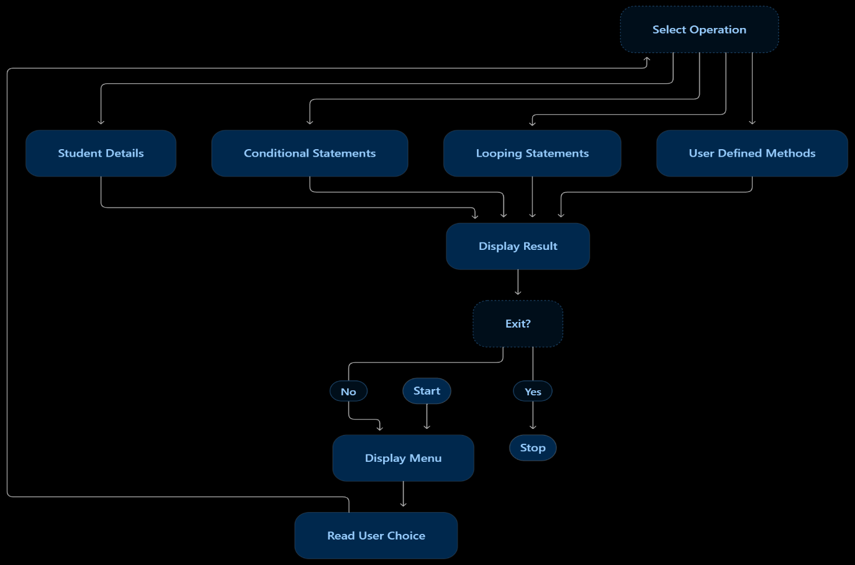

5.source code:

import java.util.Scanner;

public class StudentUtility {

static Scanner sc = new Scanner(System.in);

// Part A: Student information
static void studentInfo() {
sc.nextLine(); // Clear input buffer
System.out.print("Enter Name: ");
String name = sc.nextLine();

System.out.print("Enter Roll Number: ");
String roll = sc.nextLine();

System.out.print("Enter marks in 3 subjects: ");
double a = sc.nextDouble();
double b = sc.nextDouble();
double c = sc.nextDouble();

double total = a + b + c;
double percentage = total / 3;

System.out.println("Name: " + name);
System.out.println("Roll Number: " + roll);
System.out.println("Total Marks: " + total);
System.out.println("Percentage: " + percentage + "%");
}

// Part B: Conditional statements
static void evenOdd() {
System.out.print("Enter a number: ");
int n = sc.nextInt();
System.out.println(n % 2 == 0 ? "Even" : "Odd");
}

static void largestThree() {
System.out.print("Enter three numbers: ");
int a = sc.nextInt();
int b = sc.nextInt();
int c = sc.nextInt();
System.out.println("Largest = " +
Math.max(a, Math.max(b, c)));
}

static void grade() {
System.out.print("Enter percentage: ");
double p = sc.nextDouble();

if (p < 0 || p > 100)
System.out.println("Invalid percentage");
else if (p >= 90)
System.out.println("Grade A");
else if (p >= 75)
System.out.println("Grade B");
else if (p >= 60)
System.out.println("Grade C");
else if (p >= 40)
System.out.println("Grade D");
else
System.out.println("Fail");
}

static void dayOfWeek() {
System.out.print("Enter day number (1-7): ");
int day = sc.nextInt();

switch (day) {
case 1: System.out.println("Monday"); break;
case 2: System.out.println("Tuesday"); break;
case 3: System.out.println("Wednesday"); break;
case 4: System.out.println("Thursday"); break;
case 5: System.out.println("Friday"); break;
case 6: System.out.println("Saturday"); break;
case 7: System.out.println("Sunday"); break;
default: System.out.println("Invalid day");
}
}

// Part C: Looping statements
static void table() {
System.out.print("Enter number: ");
int n = sc.nextInt();

for (int i = 1; i <= 10; i++)
System.out.println(n + " x " + i + " = " + (n * i));
}

static void numbers() {
System.out.print("Enter N: ");
int n = sc.nextInt();

for (int i = 1; i <= n; i++)
System.out.print(i + " ");
System.out.println();
}

static void naturalSum() {
System.out.print("Enter N: ");
int n = sc.nextInt();
int sum = 0, i = 1;

while (i <= n) {
sum += i;
i++;
}
System.out.println("Sum = " + sum);
}

static void fibonacci() {
System.out.print("Enter number of terms: ");
int n = sc.nextInt();
int a = 0, b = 1;

for (int i = 1; i <= n; i++) {
System.out.print(a + " ");
int next = a + b;
a = b;
b = next;
}
System.out.println();
}

// Part D: Parameterized methods returning results
static long factorial(int n) {
long fact = 1;
for (int i = 1; i <= n; i++)
fact *= i;
return fact;
}

static boolean isPrime(int n) {
if (n < 2) return false;
for (int i = 2; i <= n / i; i++)
if (n % i == 0) return false;
return true;
}

static int maximum(int a, int b) {
return (a > b) ? a : b;
}

static double areaCircle(double r) {
return Math.PI * r * r;
}

public static void main(String[] args) {
int choice;

do {
System.out.println("\n--- STUDENT UTILITY MENU ---");
System.out.println("1. Student Information");
System.out.println("2. Even or Odd");
System.out.println("3. Largest of Three Numbers");
System.out.println("4. Grade");
System.out.println("5. Day of Week");
System.out.println("6. Multiplication Table");
System.out.println("7. Numbers from 1 to N");
System.out.println("8. Sum of Natural Numbers");
System.out.println("9. Fibonacci Series");
System.out.println("10. Factorial");
System.out.println("11. Prime Check");
System.out.println("12. Maximum of Two Numbers");
System.out.println("13. Area of Circle");
System.out.println("0. Exit");
System.out.print("Enter choice: ");
choice = sc.nextInt();

switch (choice) {
case 1: studentInfo(); break;
case 2: evenOdd(); break;
case 3: largestThree(); break;
case 4: grade(); break;
case 5: dayOfWeek(); break;
case 6: table(); break;
case 7: numbers(); break;
case 8: naturalSum(); break;
case 9: fibonacci(); break;

case 10:
System.out.print("Enter non-negative number: ");
int n = sc.nextInt();
if (n < 0 || n > 20)
System.out.println("Enter a number from 0 to 20");
else
System.out.println("Factorial = " + factorial(n));
break;

case 11:
System.out.print("Enter number: ");
System.out.println(isPrime(sc.nextInt())
? "Prime" : "Not Prime");
break;

case 12:
System.out.print("Enter two numbers: ");
int x = sc.nextInt();
int y = sc.nextInt();
System.out.println("Maximum = " + maximum(x, y));
break;

case 13:
System.out.print("Enter radius: ");
double r = sc.nextDouble();
if (r < 0)
System.out.println("Invalid radius");
else
System.out.println("Area = " + areaCircle(r));
break;

case 0:
System.out.println("Program terminated.");
break;

default:
System.out.println("Invalid choice");
}
} while (choice != 0);

sc.close();
}
}
6. Compilation and Execution Commands:
javac StudentUtility.java
java StudentUtility.
7.sample output

--- STUDENT UTILITY MENU ---
1. Student Information
2. Even or Odd
3. Largest of Three Numbers
4. Grade
5. Day of Week
6. Multiplication Table
7. Numbers from 1 to N
8. Sum of Natural Numbers
9. Fibonacci Series
10. Factorial
11. Prime Check
12. Maximum of Two Numbers
13. Area of Circle
0. Exit

Enter choice: 1
Enter Name: Gayatri
Enter Roll Number: 101
Enter marks in 3 subjects: 80 90 85
Name: Gayatri
Roll Number: 101
Total Marks: 255.0
Percentage: 85.0%

Enter choice: 10
Enter non-negative number: 5
Factorial = 120

Enter choice: 0
Program terminated.
8.output:
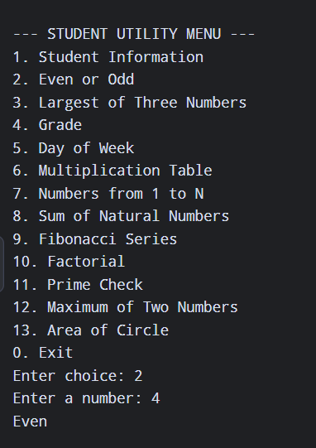
9.result:
Thus, the Student Utility Program was developed and executed successfully using Java. It demonstrates variables, input/output, conditional statements, looping statements, methods, and menu-driven programming.

